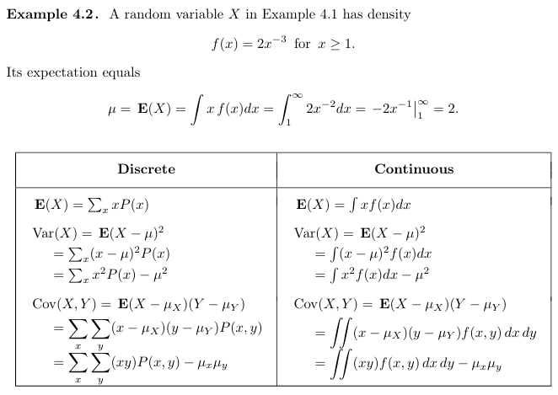
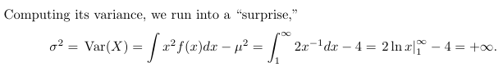

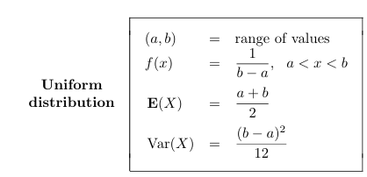

6.3 The daily amount of coffee, in liters, dispensed by a machine located in an airport lobby is a random variable X having a continuous uniform distribution with A = 7 and B = 10. Find the probability that on a given day the amount of coffee dispensed by this machine will be (a) at most 8.8 liters; (b) more than 7.4 liters but less than 9.5 liters; (c) at least 8.5 liters.
Solution:
A=7 and B=10
By Uniform Dist.
f(x) = 1/(b-a)
f(x) = 1/10-7 = 1/3

(a) at most 8.8 liters;
P (x <= 8.8) = (8.8 – 7)/3 = 0.60

(b) more than 7.4 liters but less than 9.5 liters;
P (7.4<x <9.5) = (9.5 – 7.4)/3 = 0.70

(c) at least 8.5 liters.
P (x >= 8.5) = (10 - 8.5)/3 = 0.50

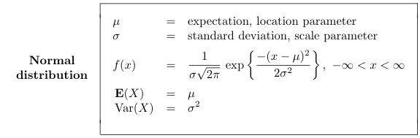
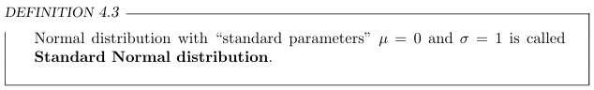
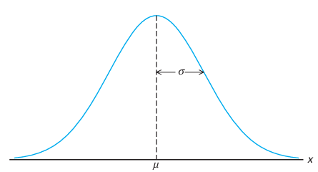
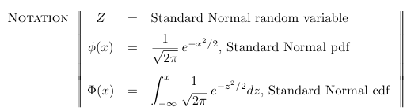

6.5 Given a standard normal distribution, find the area under the curve that lies
(a) to the left of z = −1.39;
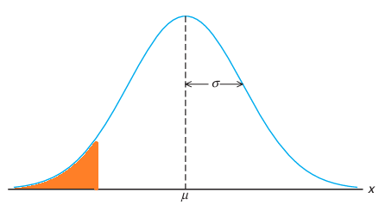
Z = - 1.39
From table A3
P( z < -1.39) = ?
Area = 0.0823

(b) to the right of z =1.96;
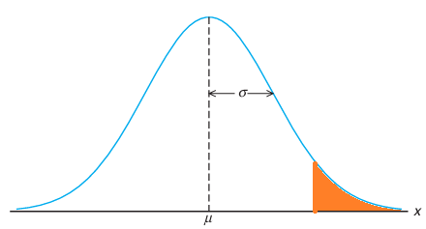
Z = 1.96
From table A3
P( z > 1.96 ) = 1 – P( z < 1.96 )
Area = 1 - 0.9750 = 0.025
(c) between z = −2.16 and z = −0.65;
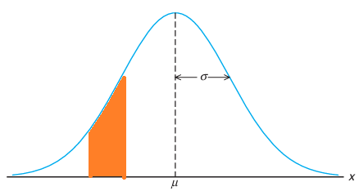
Z = - 2.16 z = - 0.65
From table A3
P(-2.16 < Z < - 0.65 )=P( z < -0.65 ) - P( z < -2.16 )
Area = 0.2578 - 0.0154 = 0.2424

(d) to the left of z =1.43;
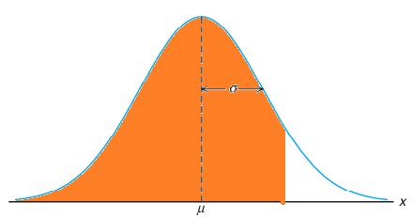
Z = 1.43
From table A3
P( z < 1.43 )
Area = 0.9236

(e) to the right of z = −0.89;
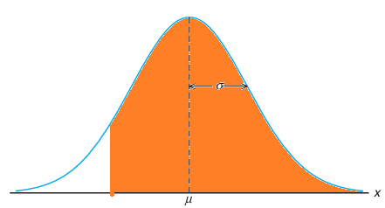
Z = - 0.89
From table A3
P( z > - 0.89 ) = 1 – P( z < - 0.89 )
Area = 1 - 0.1867 = 0.8133

(f) between z = −0.48 and z =1.74.
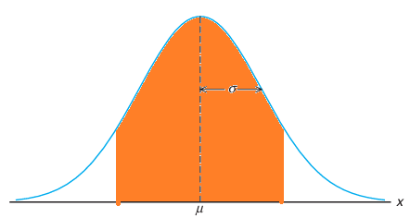
Z = -0.48 z = 1.74
From table A3
P( - 0.48 < z < 1.74 ) = P( z < 1.74 ) - P( z < -0.48 )
Area = 0.9591 - 0.3156 = 0.6435

6.6
Find the value of z if the area under a standard normal curve
(a) to the right of z is 0.3622;
(b) to the left of z is 0.1131;
(c) between 0 and z, with z > 0, is 0.4838;
(d) between −z and z, with z > 0, is 0.9500.

Solution:
(a) to the right of z is 0.3622;
P( z > k ) = 0.3622
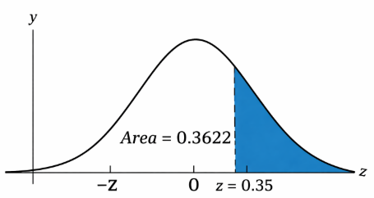

Shaded Area = 1 – 0.3622 = 0.6378
From table A3
Z = 0.35

(b) to the left of z is 0.1131;
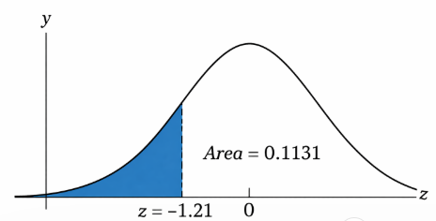
Shaded Area = 0.1131
From table A3
Z = - 1.21

(c) between 0 and z, with z > 0, is 0.4838;
P (0 < Z < z) = 0.4838

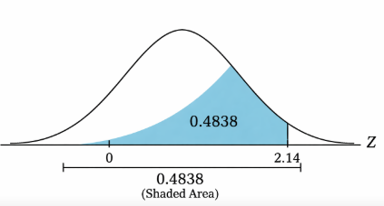
Shaded Area = 0.5 + 0.4838 = 0.9838
From table A3
Z = 2.14

(d) between −z and z, with z > 0, is 0.9500.
P (-z < Z < z) = 0.9500
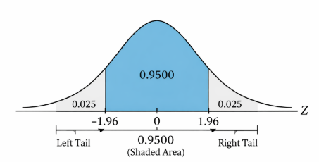
Area = 1 - 0.95 = 0.05
Area each tail = 0.05/2 = 0.025
Area = 1 - 0.025 = 0.975
From table A3
Z = 1.96

6.7 Given a standard normal distribution, find the
value of k such that
(a) P(Z>k)=0.2946;
(b) P(Z<k)=0.0427;
(c) P(−0.93 <Z<k)=0.7235.
Solution: (c)
P(z < k) - P(z < -0.93) = 0.7235-----------(1)
From table A3
Z = -0.93
Area = 0.1762
(1) => P(z < k) = 0.7235 + 0.1762 = 0.8997
From table A3
Z = 1.28

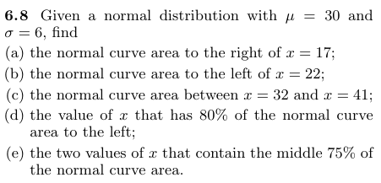
Solution:
a normal random variable Z with mean 0 and variance 1. This can be done by means of the transformation
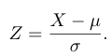
(a) the normal curve area to the right of x = 17;

The z values corresponding to x =17
Z = (17-30) / 6 = -2.17
From table A3
0.0150
Area = 1 - 0.0150 = 0.9850

(b) the normal curve area to the left of x = 22;
The z values corresponding to x =22
Z = (22-30) / 6 = - 1.33
From table A3
Area = 0.918



(c) the normal curve area between x = 32 and x = 41;
The z values corresponding to x₁ = 32 and x₂ = 41
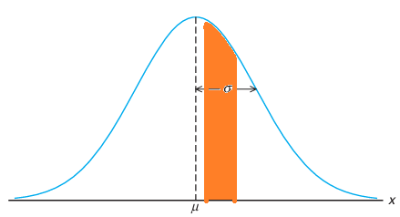
30 x₁ = 32 x₂ = 41

(d) the value of x that has 80% of the normal curve area to the left;


An area of 0.80 to the left of the desired x value is shaded in Figure. We require a z value that leaves an area of 0.80 to the left. From Table A.3
P (z < 0.84) = 0.80
Z = 0.84
The x values corresponding to z = 0.84
0.84 = (x-30) / 6
x-30 = 6(0.84)
x = 5.04 + 30
x = 34.04

(e) the two values of x that contain the middle 75% of the normal curve area.

Area = 1 – 0.75 = 0.25
Area each tail = 0.25/2 = 0.125
Area = 1 - 0.125 = 0.8750
From table A3
Z = 1.15
Z₁ = -1.15 and z₂ = 1.15

Z₁ = -1.15
Z₁ = (x₁-30)/6
-1.15 = (x₁ -30) / 6
X₁ - 30 = 6(-1.15)
X₁ = -6.9 + 30
X₁ = 23.1

Z = 1.15
Z₂ = (x₂-30)/6
1.15 = (x₂ -30) / 6
X₂ - 30 = 6(1.15)
X₂ = 6.9 + 30
X₂ = 36.9

